Car Rental Service & more

Data engineering 1 - Project Report (Team Green)

**Under the Guidance of**

Professor Frank Hefter

**Submitted By**

Aditya Raj Singh (RS, A)  
Fatemeh Shahriarizadeh (S, F)

Kartikeya Sharma (S, K)

Krupa Jayarame (J, K)

Prutha Kiran Suroshi (KS, P)

Shital Bagankar (B, S)

Tanya Goyal (G, T)

Table of Contents

Contents

**1. Introduction:** 2

2. Organization 4

2.1 Roles and Responsibilities 4

2.2 Meetings 5

2.3 Tools used 8

3. User Stories 8

4. Details 10

4.1.a.1 Send help to customer if car is not working in between 10

4.1.a.1 User Story 10

4.1.a.2 Identified Use Case 10

4.1.a.3 Actors 11

4.1.a.4 Description 11

4.1.5 Data Flow 12

4.1.a.6 Databases: 12

4.1.a.6.1 Databases used 12

4.1.a.6.2 Expression Used 12

4.1.a.7 Outcome 12

4.1.b.1 Inform to police if customer does not return the car. 12

4.1.b.1 User Story 12

4.1.b.2 Identified Use Case 13

4.1.b.3 Actors 13

4.1.b.4 Description 13

4.1.b.5 Data Flow 14

4.1.b.6 Databases: 14

4.1.b.6.1 Databases used 14

4.1.b.6.2 Expression Used 14

4.1.b.7 Outcome 14

4.2 Listing out all the cars that were present at a specific co-ordinate at a given time based on a Police Complaint 14

4.2.1 User Story 15

4.2.2 Identifying Use Case 15

4.2.3 Actors 15

4.2.4 Description 15

4.2.5 Data Flow 16

4.2.6 Databases 16

4.2.6.1 Database Used 16

4.2.6.2 Expression Used 16

4.2.7 Outcome 16

4.3 Extension of car renting time in current booking. 16

4.3.1 User Story 16

4.3.2 Identified Use Case 16

4.3.3 Actors 17

4.3.4 Description 17

4.3.5 Data Flow 17

4.3.6 Databases 17

4.3.6.1 Database used 18

4.3.6.2 Expressions Used 18

4.3.7 Outcome 18

4.4 Getting a driver for the customer 18

4.4.1 User Story 18

4.4.2 Identified Use Case 18

4.4.3 Actors 19

4.4.4 Description 19

4.4.5 Data Flow 20

4.4.6 Databases 20

4.4.6.1 Database used 20

4.4.6.2 Expressions Used 20

4.4.7 Outcome 20

4.5 Finding the cars which crossed a specific city 20

4.5.1 User Story 20

4.5.2 Identified Use Case 20

4.5.3 Actors 21

4.5.4 Description 21

4.5.5 Data Flow 21

4.5.6 Databases 22

4.5.6.1 Database used 22

4.5.6.2 Expressions Used 22

4.5.7 Outcome 22

4.6 Rescheduling the customer booking as per flight schedule 22

4.6.1 User Story 22

4.6.2 Identified Use Case 22

4.6.3 Actors 23

4.6.4 Description 23

4.6.5 Data Flow 23

4.6.6 Databases 23

4.6.6.1 Database used 24

4.6.6.2 Expressions Used 24

4.6.7 Outcome 24

4.7 Suggest better route to customer by analysing from historical data 24

4.7.1 User Story 24

4.7.2 Identified Use Case 24

4.7.3 Actors 25

4.7.4 Description 25

4.7.5 Data Flow 25

4.7.6 Databases 25

4.7.6.1 Database used 25

4.7.6.2 Expressions Used 26

4.7.7 Outcome 26

List of Tables

Table 1 : Roles and Responsibilities 6

Table 2 : Responsibilities Definition 6

Table 3: Team Meetings 9

Table 4 : Tools Description 10

List of Figures

Figure 1 : Use Case 1.a - UML 13

Figure 2 : Use Case 1.a - DFD 14

Figure 3 : Use Case 1b - DFD 15

Figure 4 : Use Case 1.b - DFD 16

Figure 5 : Use Case 2 - UML 17

Figure 6 : Use Case 3 - UML 19

Figure 7 : Use Case 4 - UML 21

Figure 8 : Use Case 5 - UML 23

Figure 9 : Use Case 5 - DFD 24

Figure 10 : Use Case 6 - UML 25

Figure 11 : Use Case 7 - UML 27

# **1. Introduction:**

In today’s times, not everyone can afford to own and maintain vehicles, so often they turn to renting one instead. This not only provides an effective option for travel, but also gives a luxury to experience premium vehicles which cannot be owned by everyone. To rent a vehicle of their choice, people generally go to car rental firms in order to find the right vehicle for their needs. This can take up a lot of time and energy. To simplify this process and make it more convenient for customers, there is an increasing need for a platform that allows people to easily search for rental cars with minimal effort. This can be especially important during busy times of the year, when people need reliable, comfortable transportation to get them to their destinations on time.

The “Car Rental System” is intended to give a digital platform to the daily activities and transactions in a car rental business and its customers. This project is an online portal that displays cars for rent. It is a digital system that allows car owners to upload and post the details of their cars for rent and users can go through the available cars that will cater to their requirements and book a vehicle of their choice as well according to their time. This system eliminates the effort required and time consumed in traditional car rental service, where the user must personally visit such firms to rent a vehicle.

# 2. Organization

## 2.1 Roles and Responsibilities

|  |  |  |  |  |  |  |  |
| --- | --- | --- | --- | --- | --- | --- | --- |
| **Tasks** | **Team Members** | | | | | | |
| **RS, A** | **S, F** | **S, K** | **J, K** | **KS, P** | **B, S** | **G, T** |
| Brainstorming | R | R | R | R | R | R | R |
| Requirements Gathering | R | R | R | R | R | R | R |
| Selection of Databases | R | R | R | R | R | R | R |
| Data Setup | R | R | R | R | R | R | R |
| Databases Setup | R | R | R | R | R | R | R |
| UML Diagram | R | R | R | R | R | R | R |
| Data Flow Diagram | R | R | R | R | R | R | R |
| Report Documentation | R | R | R | R | R | R | R |
| User Stories | R | R | R | R | R | R | R |
| Use Case 1 | C | C | R | C | C | C | C |
| Use Case 2 | R | C | C | C | C | C | C |
| Use Case 3 | C | C | C | C | C | R | C |
| Use Case 4 | C | C | C | C | C | C | R |
| Use Case 5 | C | R | C | C | C | C | C |
| Use Case 6 | C | C | C | C | R | C |  |
| Use Case 7 | C | C | C | R | C | C | C |

Table 2 : Roles and Responsibilities

|  |  |
| --- | --- |
| **Responsibilities Definition** | |
| R | Responsible |
| C | Consulted |

Table 3 : Responsibilities Definition

## 2.2 Meetings

|  |  |  |
| --- | --- | --- |
| Team Blue – Meeting 1 | | |
| Date: 15/01/2023 | Time: 15:30 – 17:00 | Location: MS Teams |
| Participants | Aditya Raj Singh  Fatemeh Shahriarizadeh  Kartikeya Sharma  Krupa Jayarame  Prutha Kiran Suroshi  Shital Bagankar  Tanya Goyal | |
| Discussion | * Project kick-off * Topic Overview * Possible use cases (Basic level) | |
| Actions | Prepared more ideas about the use cases | |
| Conclusions | Finalized basic use cases to discuss with professor | |

|  |  |  |
| --- | --- | --- |
| Team Blue – Meeting 2 | | |
| Date: 20/01/2023 | Time: 15:30 – 16:03 | Location: MS Teams |
| Participants | Aditya Raj Singh  Fatemeh Shahriarizadeh  Kartikeya Sharma  Krupa Jayarame  Prutha Kiran Suroshi  Shital Bagankar  Tanya Goyal  Prof Frank Hefter | |
| Discussion | * Discussed about the project we took * Need to do total 7 use cases * Got few sources for GPS related data from Professor | |
| Actions | Need to create user story which has some real-world problems which customer and car rental services are facing | |
| Conclusions | To prepare more user stories. | |

|  |  |  |
| --- | --- | --- |
| Team Blue – Meeting 3 | | |
| Date: 23/01/2023 | Time: 10:30 – 16:30 | Location: ARC- 005 |
| Participants | Aditya Raj Singh  Fatemeh Shahriarizadeh  Kartikeya Sharma  Krupa Jayarame  Prutha Kiran Suroshi  Shital Bagankar  Tanya Goyal | |
| Discussion | * Discussed 12 user stories with team * Decided to present this to professor | |
| Actions | Decided to present this to professor | |
| Conclusions | If user stories approved then proceed with the data modelling and system design | |

|  |  |  |
| --- | --- | --- |
| Team Blue – Meeting 4 | | |
| Date: 23/01/2023 | Time: 16:30 – 17:12 | Location: MS Teams |
| Participants | Aditya Raj Singh  Fatemeh Shahriarizadeh  Kartikeya Sharma  Krupa Jayarame  Prutha Kiran Suroshi  Shital Bagankar  Tanya Goyal  Prof. Frank Hefter | |
| Discussion | * Discussed 12 user stories with professor. * Professor modified few user stories so that it may have more advanced problems * And professor gave hints about the new user stories | |
| Actions | 4 user stories accepted and few modified by professor | |
| Conclusions |  | |

|  |  |  |
| --- | --- | --- |
| Team Blue – Meeting 5 | | |
| Date: 24/01/2023 | Time: 11:30 – 16:30 | Location: ARC - 005 |
| Participants | Aditya Raj Singh  Fatemeh Shahriarizadeh  Kartikeya Sharma  Krupa Jayarame  Prutha Kiran Suroshi  Shital Bagankar  Tanya Goyal | |
| Discussion | * After brainstorming created 5 more user stories * Uploaded these user stories to Team blue MS-Teams and got the feedback from the professor * 3 more user stories got approved/modified by professor. | |
| Actions | Need to create the report till 4.x by taking the example of good report shared by professor. | |
| Conclusions | Need to create the report till 4.x by taking the example of good report shared by professor. | |

|  |  |  |
| --- | --- | --- |
| Team Blue – Meeting 6 | | |
| Date: 25/01/2023 | Time: 14:00 – 14:30 | Location: MS-Teams |
| Participants | Aditya Raj Singh  Fatemeh Shahriarizadeh  Kartikeya Sharma  Krupa Jayarame  Prutha Kiran Suroshi  Shital Bagankar  Tanya Goyal | |
| Discussion | * Collected the use cases from the team * Create the report till 4.x and present to professor. | |
| Actions |  | |
| Conclusions | Need to create the report till 4.x by taking the example of good report shared by professor. And share it to professor | |

Table 4: Team Meetings

## 2.3 Tools used

|  |  |
| --- | --- |
| **Area** | **Tools** |
| Databases | Neo4j Desktop Neo4j Driver MongoDB Driver MongoDB Compass Redis |
| Languages | Python |
| IDE | Visual Studio Code (Python) |
| Version Control | Git GitHub |
| ERD | Visual Paradigm |
| Documentation | Microsoft Word Adobe PDF |
| UML | Visual Paradigm |
| DFD | Lucid Chart |

Table 5 : Tools Description

# 3. User Stories

**User Stories- Searching for GPS of the Cars**

* **As a customer I am worried if my car breaks down somewhere in the middle. So what the system going to help me. .  ---- 1st user story confirmed by professor**
* **As an admin I make sure the car is returned by the customer on the mentioned date and time, but the car is not returned on the end rental time. I tried to reach the customer, but the customer is not reachable. So first I have checked the recent GPS co-ordinates of the rented car in our database. and then informed the police.  ---- 1st user story confirmed by professor**

* **Police reported a rented car caused an accident. The car had a red mark. Police has the gps coordinates of the accident. Hand out the list of all cars that have been at this palce in the given time. ( range check with gps and time, simulate tracks over time) ---- 2nd user story confirmed by professor**

* **Company orders 50 cars for their employees to drive to a festival. Now the festival is extended. Write a routine to not just extend the lending time of all cars but also handle the already existing orders for these cars in the time. ---- 3rd user story confirmed by professor**

**User Stories- Customer’s Requests**

* ~~As a customer, I want to extend my current booking.~~
* ~~As a customer, I need a discount and as an admin I need to check the customer rating and based on that we will decide to provide or not to provide the discount.~~
* **As a customer, I want a driver as I can't drive the car. (Neo4j, pool of drivers somewhere, customer and car have to be organized) ---- 4th   user story confirmed by professor**
* ~~As a customer, I need the car to be delivered to my location. With prepaid fueling and I need the choice of car (Fuel, Hybrid, Electric)~~

**User Stories- Return Conditions**

* ~~As an admin, I want to ensure the car is returned in the same condition as it was handed over else the security amount will be deducted.~~
* ~~As an admin, I need to make sure that car returned with the same amount of fuel as it was handed over, otherwise customer will be charged.~~

**User Stories- Attract more Customers**

* ~~As an admin, I want to attract more sales or customers, So I want to create promotional offers / discount  (for regular and new customer).~~
* ~~As an admin, I want to check which car is more in demand and updating the rental price of the car.~~

**New User Stories Suggested (To be reviewed by professor /Done)**

5. As an ~~Admin~~Accountant, I must create an invoice for the Customer after the trip has ended based on the vehicle, Distance Travelled, Fuel Consumed and Time taken during the entire trip.  This depends on Various factors such as the the category of the car rented. Basic category will have less price when compared to Premium category which will cost more.

Another point of discussion is, we will allot initial hours and kms of ride to the car irrespective of the days booked and when this time or kms exceed, it will again cost 10 cents per minute and 10 cents per kilometer and final invoice will be shared to the customer.**---(To be reviewed by professor / Not accepted. But...)**

What you are doing here is constructing complicated business use cases but nothing that needs a NOSQL database.    
I accept this use case if: You use Neo4j and construct a database that helps you to do this calculation easier and more flexible.    
This means you have the above calculation model in the database stored and link the invoice creation to this “somehow”. So that a change in the database will change (not just the 10cent but also a few business model changes) the result and the factors of the calculation, too. I underlined the parts that should go into the database and can be switched on and off or be modified with its factors. Historical changes should be possible and comprehensible for later audits (financial office / customer/...).

6. Our company has a mutual project, and we want to do some advertisement for them by sticking their products' images on our cars. They want to know how much their advertisement done by us has been beneficial in a specific district and duration of time. So, I as an admin (Who exactly?) want to know how many of my cars crossed that specific district (I have to know the coordinates of the paths that my cars had in that specific time duration). **---(To be reviewed by professor (Accepted for 10 cars or more) )**

7. As a Customer, I will be returning to my town after a Business trip and I would have booked a rented car. But unfortunately, the flight got delayed and I cannot inform this to the car renting service. So as an Admin? of the Car renting service, we will keep a track of the flight schedule and change the Booking time accordingly. **---(To be reviewed by professor (Accepted if: Please take the live flightplan details from a source I can name you))**

8. As a customer, I want to book a car for 3 months for my summer vacation. As an admin, if a customer books a car for 3 months then he/she will be charged 50% of the daily charges for 3 months plus the security amount. **---(To be reviewed by professor (Not accepted))**

9. As an Admin, our company has a tie up with a tourist company and we take care of the transportation of the guests across the city.  **---(To be reviewed by professor (Not accepted))**

10. According to users travel history which kind of places he visits, we are suggesting him these kind of places in the future with offers which will include, hotels, restaurants, upcoming events in those areas. **---(To be reviewed by professor (Not accepted))**

11. Our system has historical data of previous customers, analyzing it we are suggesting better routes, for next customers who are visiting same location.  **---(To be reviewed by professor (Accepted if: A lot of data is used and the plans are more detailed))**

# 4. Details

## 4.1.a.1 Send help to customer if car is not working in between

## 4.1.a.1 User Story

As a customer I need help from the Car rental service (Admin) as the car is not working in between. So as an admin will check the GPS location of the customer and the location of the nearest service station of the car rental service and send the help, if the car is not fixed in the given time of span, then a new car will be delivered to the customer from the nearest service station.

## 4.1.a.2 Identified Use Case

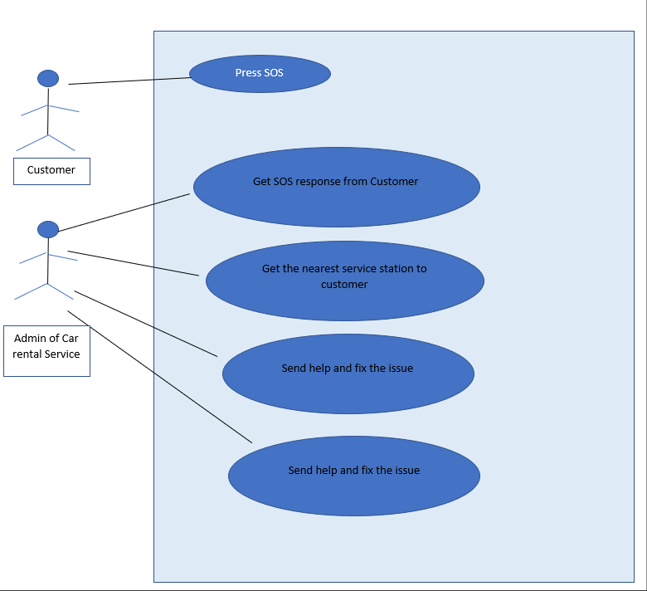

Figure 1 : Use Case 1.a - UML

## 4.1.a.3 Actors

• Customer

• Admin (Car rental Service)

## 4.1.a.4 Description

Customer will send the SOS event to the admin (Car rental Service) and then admin will check the GPS location of the customer and then will send the help from the nearest service Centre, if the car is not fixed within a given time span, then the admin will check the availability of the new car in the nearest service Centre and send it to the customer location

## 4.1.5 Data Flow

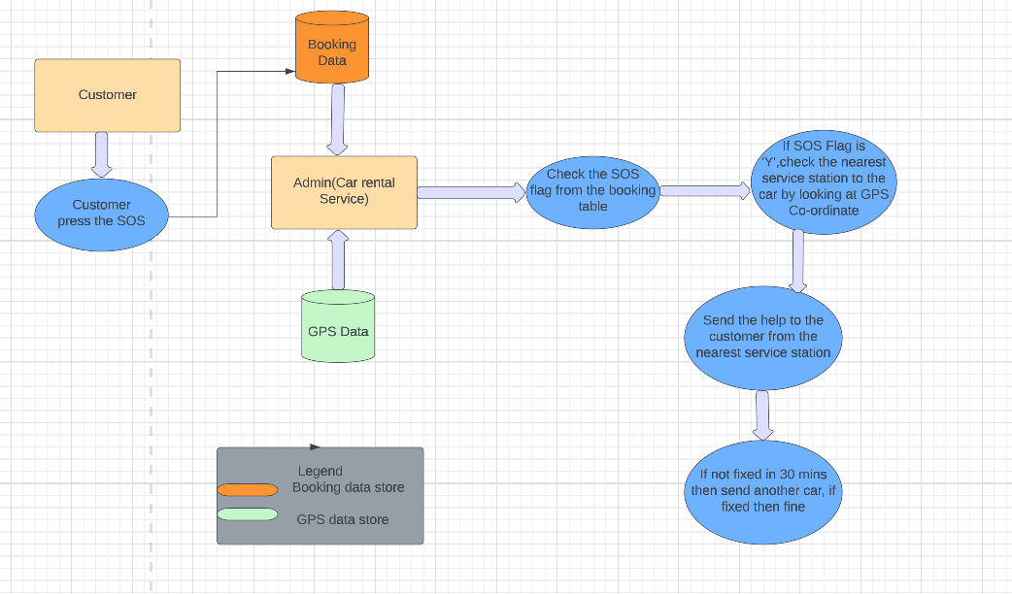

Figure 2 : Use Case 1.a - DFD

## 

## 4.1.a.6 Databases:

MongoDB

Neo4j

### 4.1.a.6.1 Databases used

We are using MongoDB as base and presentation layer in Neo4j

### 4.1.a.6.2 Expression Used

## 4.1.a.7 Outcome

## 4.1.b.1 Inform to police if customer does not return the car.

## 4.1.b.1 User Story

As an admin I make sure the car is returned by the customer on the mentioned date and time, but the car is not returned on the end rental time. I tried to reach the customer, but the customer is not reachable. So first I have checked the recent GPS co-ordinates of the rented car in our database. and then informed the police

## 4.1.b.2 Identified Use Case

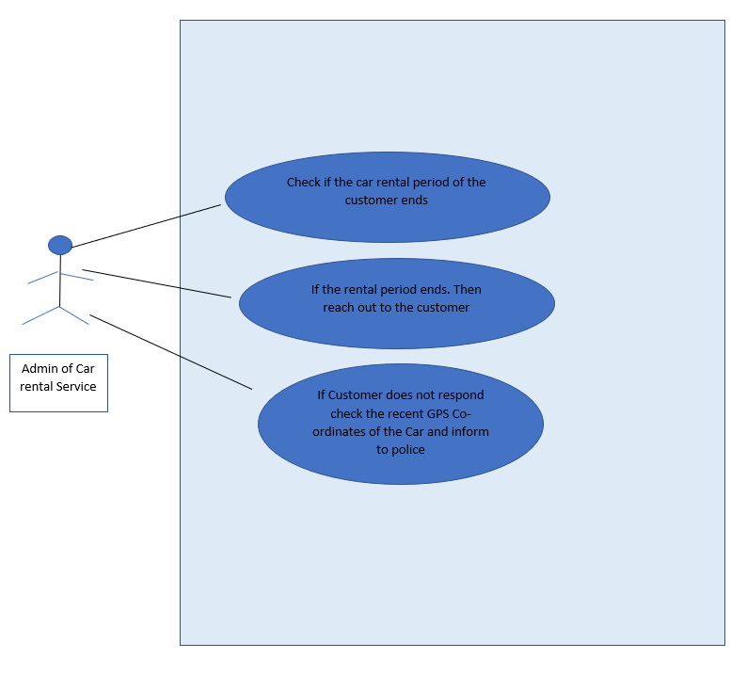

Figure 3 : Use Case 1b - DFD

## 4.1.b.3 Actors

• Admin (Car rental Service)

## 4.1.b.4 Description

As an admin I make sure the car is returned by the customer on the mentioned date and time, but the car is not returned on the end rental time. I tried to reach the customer, but the customer is not reachable. So first I have checked the recent GPS co-ordinates of the rented car in our database. and then informed the police

## 4.1.b.5 Data Flow

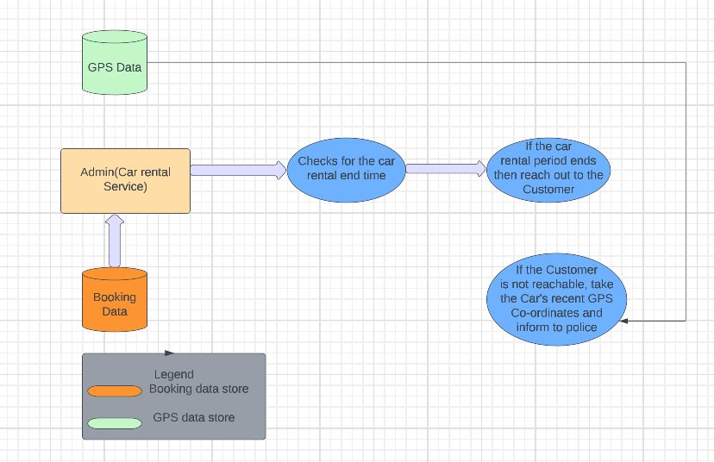

Figure 4 : Use Case 1.b - DFD

## 

## 4.1.b.6 Databases:

MongoDB

Neo4j

### 4.1.b.6.1 Databases used

We are using MongoDB as base and presentation layer in Neo4j

### 4.1.b.6.2 Expression Used

## 4.1.b.7 Outcome

## 4.2 Listing out all the cars that were present at a specific co-ordinate at a given time based on a Police Complaint

## 4.2.1 User Story

As an Admin, checking and listing all the cars that had a red mark on it and were present at a specific location at a given time frame based on a Police Report

## 4.2.2 Identifying Use Case

Figure 5 : Use Case 2 - UML

## 

## 4.2.3 Actors

* Admin
* Police

## 4.2.4 Description

The Admin of the Car Rental Company has received a Police Report stating one of the rented cars has been suspected to have caused an accident. It has a red mark on it. They have also shared all the details such as time and the co-ordinates of the location.

Based on the information, Admin will check if any of the rented car of our company was present at the time and place of the accident and report back to the police

## 4.2.5 Data Flow

## 4.2.6 Databases

### 4.2.6.1 Database Used

### 4.2.6.2 Expression Used

## 4.2.7 Outcome

## 4.3 Extension of car renting time in current booking.

## 4.3.1 User Story

The organization X has booked 50 cars on rent, for two days, for their annual event. As an event manager of this organization, I want to extend this ongoing booking time for four days, as there are change in plans.

As an admin of the Car Rental Service, I want to extend renting time for this user (organization X). And accordingly, will arrange the bookings of the customers (whose bookings are going to affect due to this scenario)

## 4.3.2 Identified Use Case

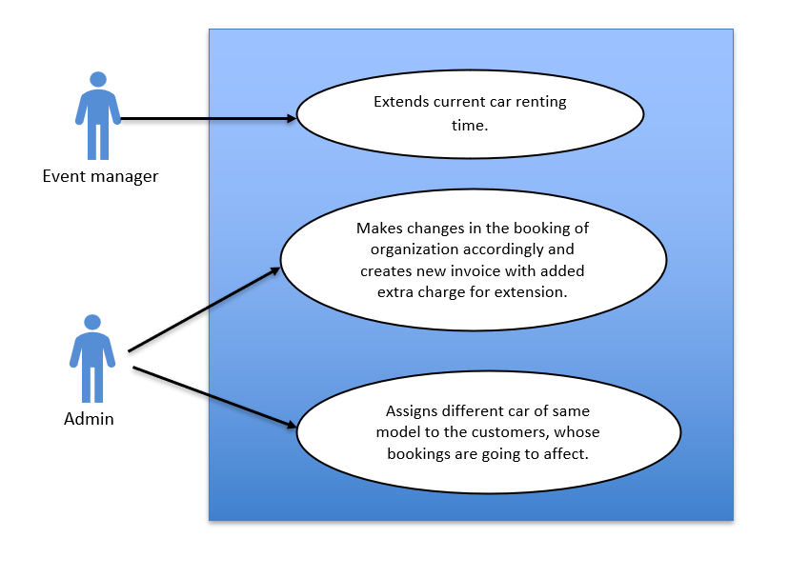

Figure 6 : Use Case 3 - UML

## 4.3.3 Actors

• Event manager of the organization X.

• Admin of Car Rental Service.

## 4.3.4 Description

For an annual event, the Organization X booked 50 cars, for two days. Due to change in event plans, they want to extend the renting time from two days to four days.

The admin of the Car Rental Service acknowledges the issue and extends the renting time for this user (organization X). And generates the new invoice, including extra charges for extension. The users, whose booking is going to affected due to this scenario, they will be allotted the same car, the one they previously booked. Unfortunately, if that car is not available, other cars are provided to these users according to their choice.

## 4.3.5 Data Flow

## 4.3.6 Databases

### 4.3.6.1 Database used

### 4.3.6.2 Expressions Used

## 4.3.7 Outcome

## 4.4 Getting a driver for the customer

## 4.4.1 User Story

I want to hire a driver for my travel along with the booking of the car, as I cannot drive.

## 4.4.2 Identified Use Case

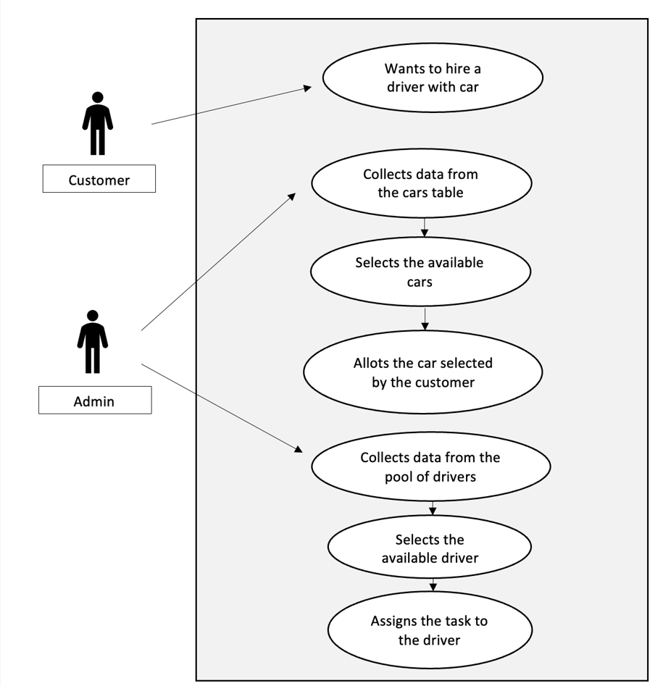

Figure 7 : Use Case 4 - UML

## 

## 4.4.3 Actors

• Customer

• Admin (Car rental Service)

## 4.4.4 Description

The customer wants to hire a driver for 3 days along with the car booking.

The admin of the Car Rental Service analysis the requirements of the customer and fetches data , the availability of the drivers for those particular dates, the availability of the car required by the customer for those particular dates and the nearest station from where the service can be provided to the customer.

## 4.4.5 Data Flow

## 4.4.6 Databases

### 4.4.6.1 Database used

### 4.4.6.2 Expressions Used

## 4.4.7 Outcome

## 4.5 Finding the cars which crossed a specific city

## 4.5.1 User Story

As an admin, I want to find my cars which crossed a specific city over a specific time duration. I am in collaboration with another company whose ads are stuck on my cars and they want to know the effect of these ads in a specific city.

## 4.5.2 Identified Use Case



Figure 8 : Use Case 5 - UML

## 

## 4.5.3 Actors

• Customer (Collaborative Company)

• Admin (Car rental Service)

## 4.5.4 Description

As an admin, I want to find my cars which crossed a specific city over a specific time duration. I am in collaboration with another company whose ads are stuck on my cars and they want to know the effectiveness of these ads in a specific city. I have to give a report to that company to show him:

* how many cars crossed the city they need information about;
* how many kilometers they passed in that specific city;
* how long they spend time in that specific city.

Therefore, I have to find the routs that these cars had and create the report for the company using the information (data) of those specific routs.

## 4.5.5 Data Flow

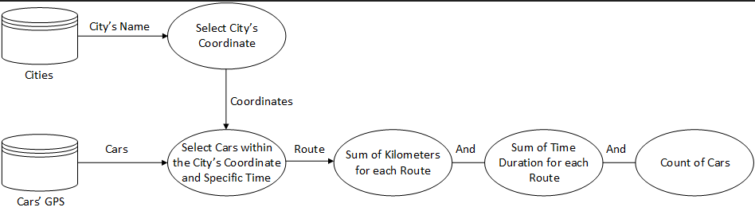

Figure 9 : Use Case 5 - DFD

## 

## 4.5.6 Databases

### 4.5.6.1 Database used

### 4.5.6.2 Expressions Used

## 4.5.7 Outcome

## 4.6 Rescheduling the customer booking as per flight schedule

## 4.6.1 User Story

If customer will be returning from business trip to his town and want to book a rented car. But sadly, the flight got delayed and unable to inform to the car renting service. Then admin of the car renting service will keep a track of the flight schedule and change the booking time as per the flights.

## 4.6.2 Identified Use Case

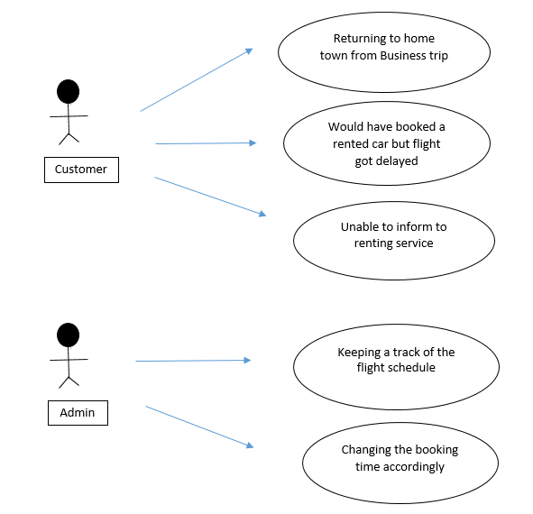

Figure 10 : Use Case 6 - UML

## 

## 4.6.3 Actors

• Customer

• Admin (Car rental Service)

## 4.6.4 Description

If customer will be returning from business trip to his town and want to book a rented car. But sadly, the flight got delayed and unable to inform to the car renting service. Then admin of the car renting service will keep a track of the flight schedule and change the booking time as per the flights.

## 4.6.5 Data Flow

## 4.6.6 Databases

### 4.6.6.1 Database used

### 4.6.6.2 Expressions Used

## 4.6.7 Outcome

## 4.7 Suggest better route to customer by analysing from historical data

## 4.7.1 User Story

As an Admin we check all reviews of routes from customers, then collect historical data of previous customers and analyse the best routes and suggest routes for future customers visiting the same destinations.

## 4.7.2 Identified Use Case

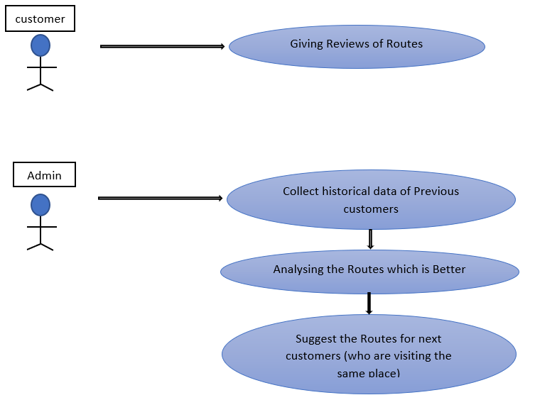

Figure 11 : Use Case 7 - UML

## 4.7.3 Actors

• Customer

• Admin (Car rental Service)

## 4.7.4 Description

As an Admin we check all reviews of routes from customers, then collect historical data of previous customers and analyse the best routes and suggest routes for future customers visiting the same destinations.

## 4.7.5 Data Flow

## 4.7.6 Databases

### 4.7.6.1 Database used

### 4.7.6.2 Expressions Used

## 4.7.7 Outcome